**CPC 4 JAVA**

**Задание №1.**

int n=5;  
int [] a = new int[n];  
  
for(int i=0;i<n;i++){  
 a[i] = i*(i+1);  
 System.*out*.println(a[i]);

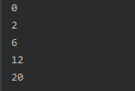

**Задание №2.**

int n=5;  
int [] a = new int[n];  
int x = 9;  
for(int i=0;i<n;i++){  
 a[i] = x%2;  
 System.*out*.println(a[i]);

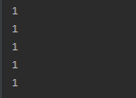

**Задание №3.**

int n=5;  
int [] a = new int[n];  
  
int x=7;  
for(int i=0;i<n;i++){  
 a[i]=i==0 ? 0: x%i;  
 System.*out*.println(a[i]);

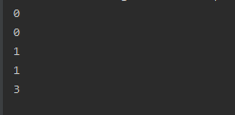

**Задание №4.**

int n=5;  
int [] a = new int[n];  
int x = 8;  
for(int i=0;i<n;i++){  
 x = (int)(90*Math.*random*()+10);  
 a[i] = x/10;  
 System.*out*.println(a[i]);

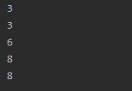

**Задание №6.**

int n=5;  
int [] a = new int[n];  
int x = (int) (Math.*random*()*99+1);  
for(int i=0;i<n;i++){  
 a[i] = x;  
 x=x+x%10;  
 System.*out*.println(a[i]);

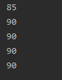

**Задание №7.**

int n=5;  
int [] a = new int[n];  
int x = (int) (Math.*random*()*100);  
for(int i=0;i<n;i++){  
 a[i] = x;  
 x=(int)(x+Math.*random*()*100);  
 System.*out*.println(a[i]);

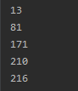

**Задание №8.**

int n=5;  
int [] a = new int[n];  
int x = 11;  
for(int i=0;i<n;i++){  
 a[i] = x;  
 a[n-1-i]=a[i];  
 System.*out*.println(a[i]);

